|  |  |  |
| --- | --- | --- |
| VILNIAUS KOLEGIJA  UNIVERSITY OF APPLIED SCIENCES  FACULTY OF ELECTRONICS AND INFORMATICS | | |
| https://screenshotscdn.firefoxusercontent.com/images/eaf3f7f3-2952-4801-af5c-4f20e8ae8b88.png | | |
|  | | |
| **PRACTICAL WORK ODOO** | | |
|  | | |
| PRACTICAL WORK  6531BX028 PI18E | | |
| STUDENTS | (SIGNATURE) | EDITA KOMAROVA |
| 2020-04 |
|  |
|  |
|  |
|  |
|  |
| LECTURER |  | TATJANA LIOGIENĖ | |
|  | (SIGNATURE) |  |
|  | 2020-04 |  |
| 2020 | | |

Contents

INTRODUCTION 3

1. 4

2. 4

3. 5

4. 11

CONCLUSION 12

# INTRODUCTION

Goal: Add additional Odoo modules and configure them.

Tasks: 1. To prepare short introduction about the company (you can select the same company as selected in Information Systems course) describing it‘s aim and products or services the company provides.

2. To select and present the ODOO modules you have chosen to install in a company. To reason the selection of modules use company Data Flow Diagram (DFD).

3. To analyze and demonstrate the functionality of offered modules, using company sample data (entered manually).

4. Configure the chosen modules.

# 1.

Online Book Store

Purpose: To sell books online to the customers.

Goals: Provide customers a fast and comfortable delivery of books.

Products: Books.

Services: Deliver books and give refund.

# 2.

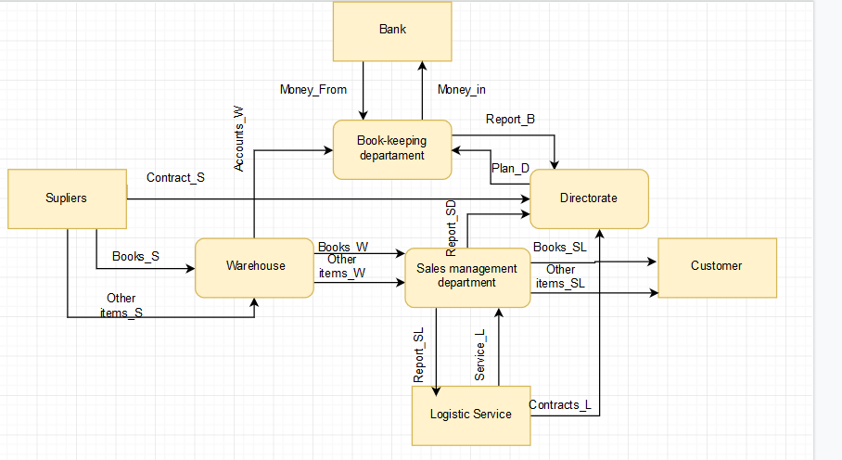

Figure 1- Level 0 DFD diagram

Table 1 -Main activities

|  |  |  |
| --- | --- | --- |
| Process name | Odoo module | Comments |
| Book-keeping department | Sales module, Purchase management, Invoice management. | Book-keeping departments is allowed to check the Sale’s department reports |
| Warehouse | Inventory and Contacts. | Warehouse manages the Inventory and use Contacts module to order supplies from vendors |
| Directorate | Employees, Attendance, Sales, Purchase, Invoice management. | Directorate looking after employees and have right to check the reports. |
| Sales management department | Sales module, Purchase, Invoice, Email Marketing. | Sales managements have a right to confirm the sales and send invoices. |

# 3.

The Inventory module helps to create new items and edit their information about it.

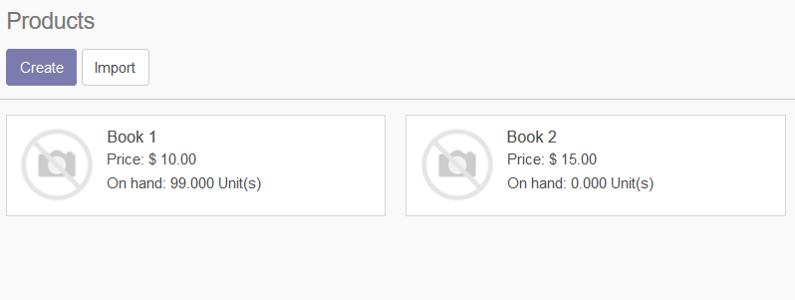

Figure 2 - Items in the Inventory

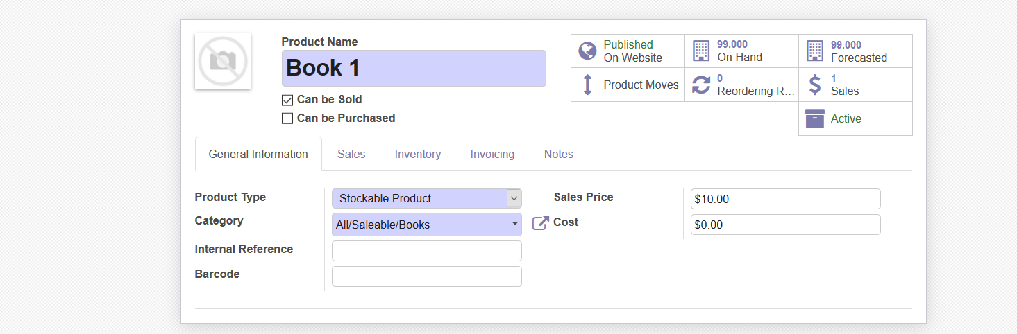

Figure 3- Editing Product information

The employee can edit information, price and quantities. Also employee is able to archive the items if it’s no longer selling.

Sales Module helps the company to create a Quotation.

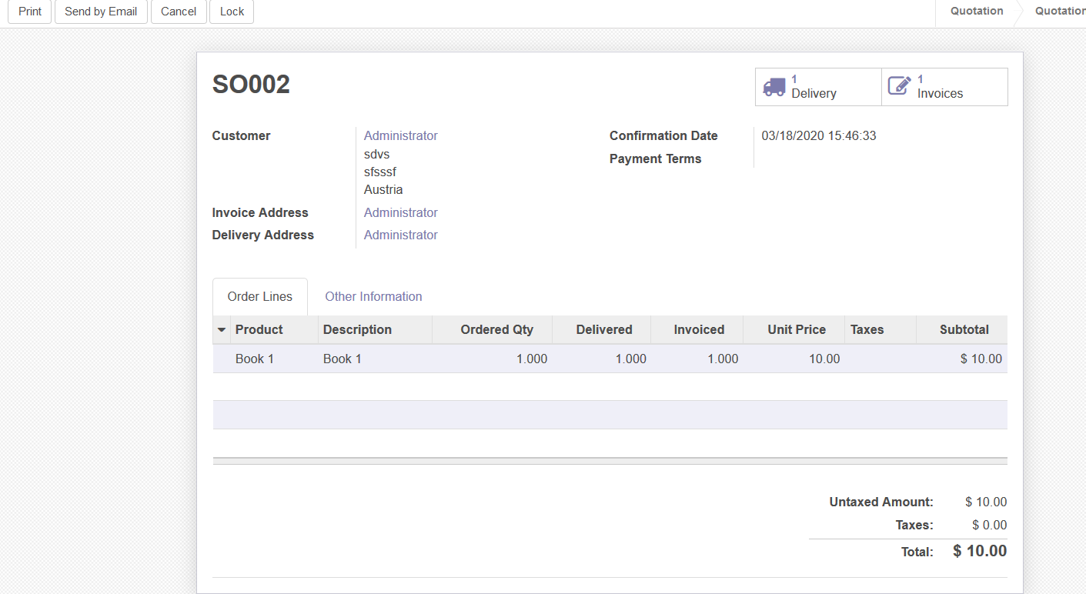

Figure 4 – Quotation

Also you can send automatic email of quotation to the client.

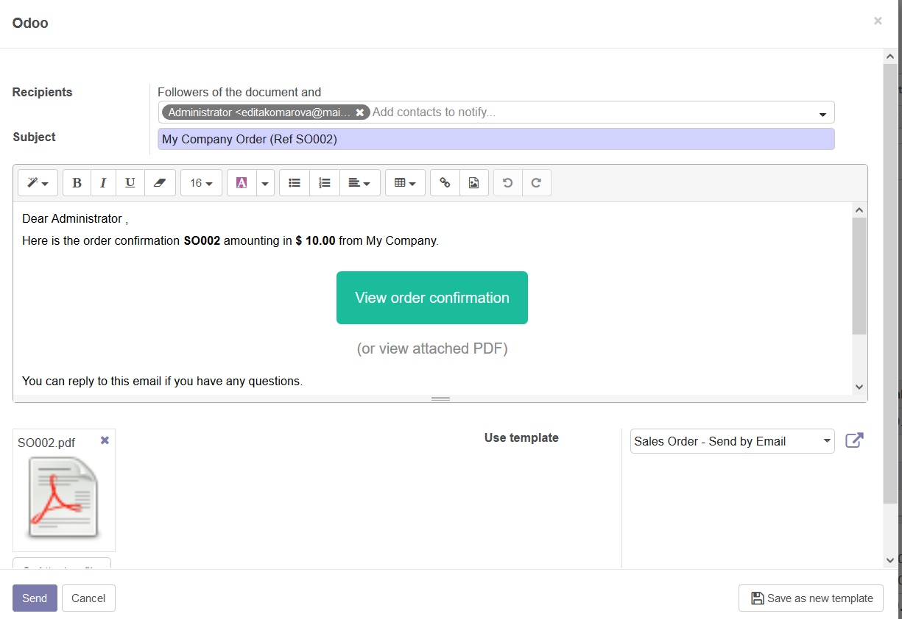

Figure 5- Email

eCommerce module is integrated with the Website module.



Figure 6- Website

Customer is able to buy books from the shop and administrator can publish items or unpublish.

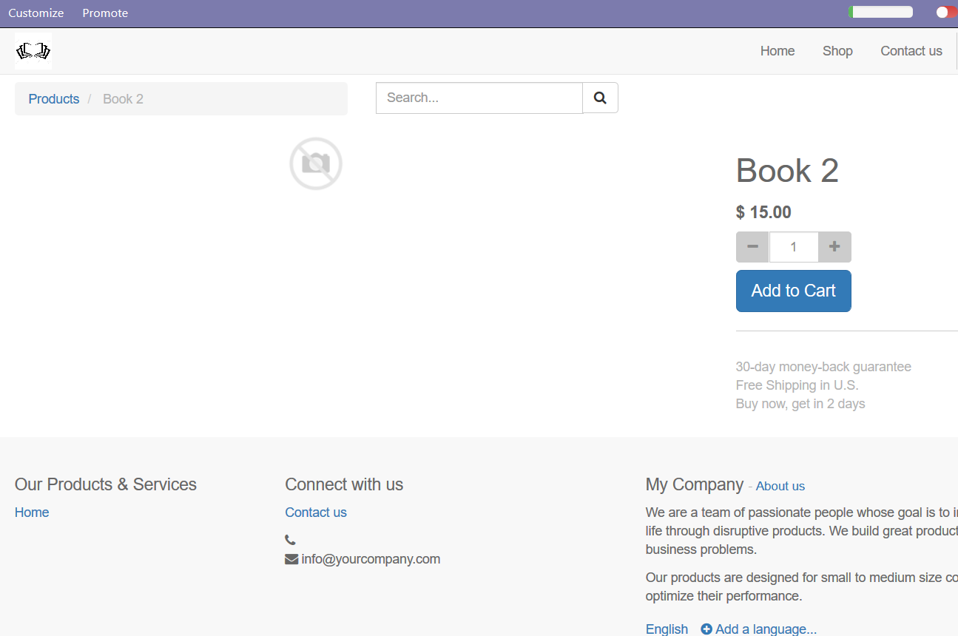

Figure 7- eCommerce store

Customer can add items to the Shopping cart and pay for it.

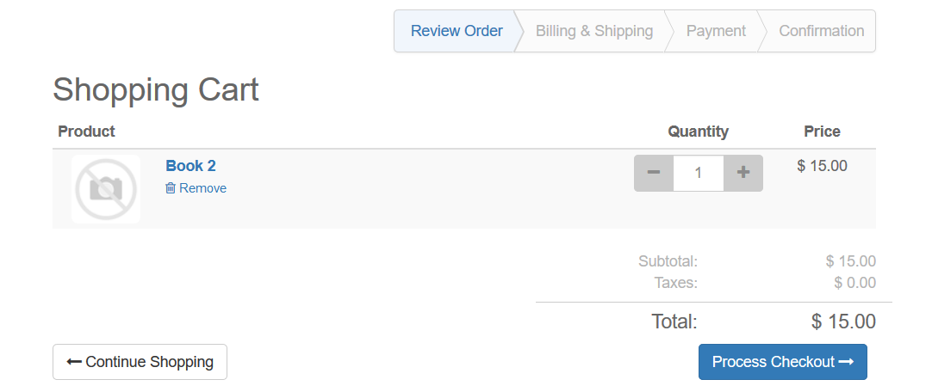

Figure 8 - Shopping Cart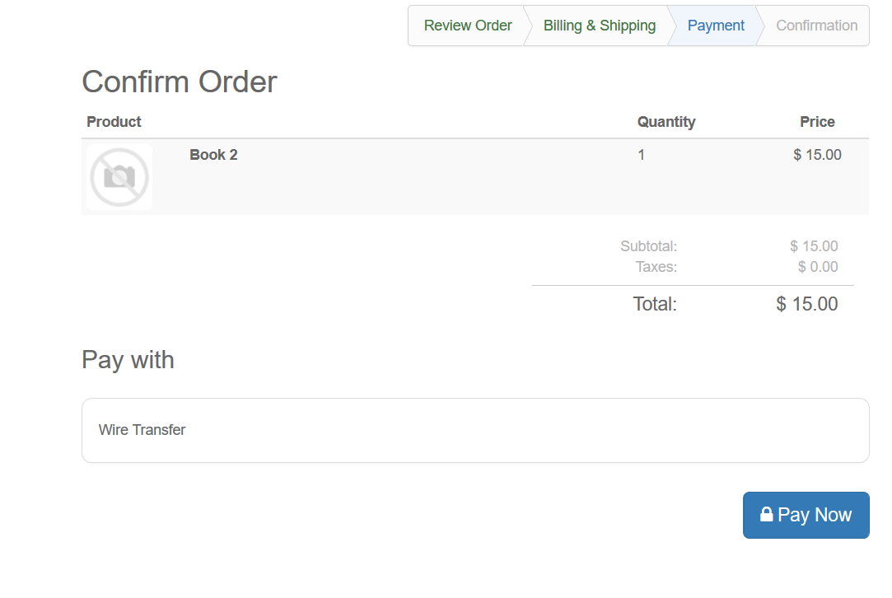

Figure 9- Select Payment

After paying for the item the order travels to Sale’s and Invoice module, where the employees can see and prepare client’s order.

The Employee module helps to add new workers information assign position and working hours.

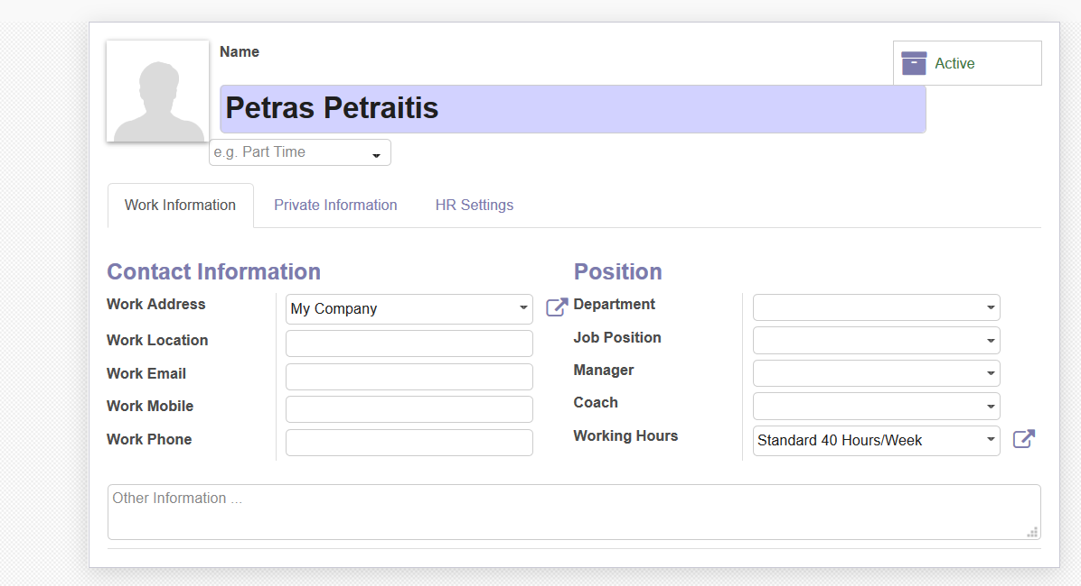

Figure 10 - Employee information

It also allows to create a new position.

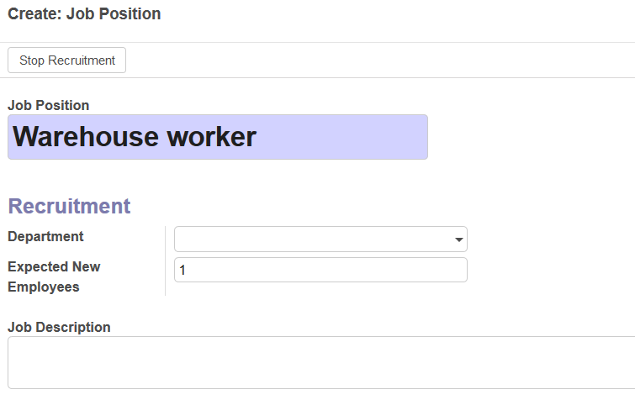

Figure 11- Creating the new job position

Employee module allow us to create department and assign manager to the department.

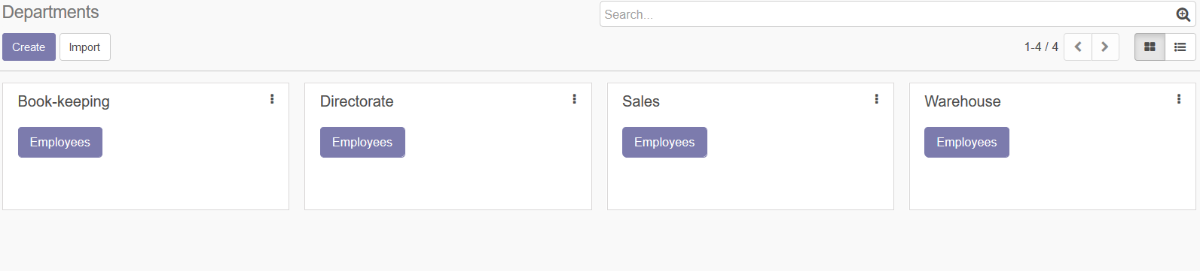

Figure 12 - Department

The Attendance module is integrated in Employees module and helps us see if the employee is present. The green indicator tells us that employee is present the red indicator means that employee is absent.

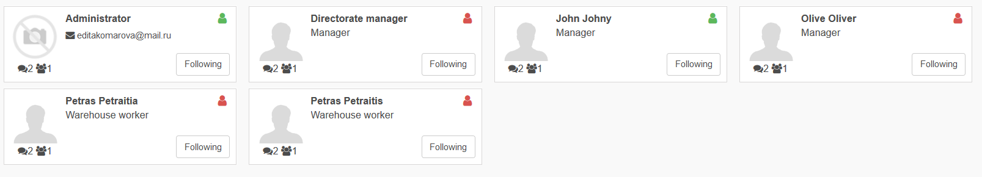

Figure 13 - The usage of the indicators.

The module also allows employees to check in theire attendance.

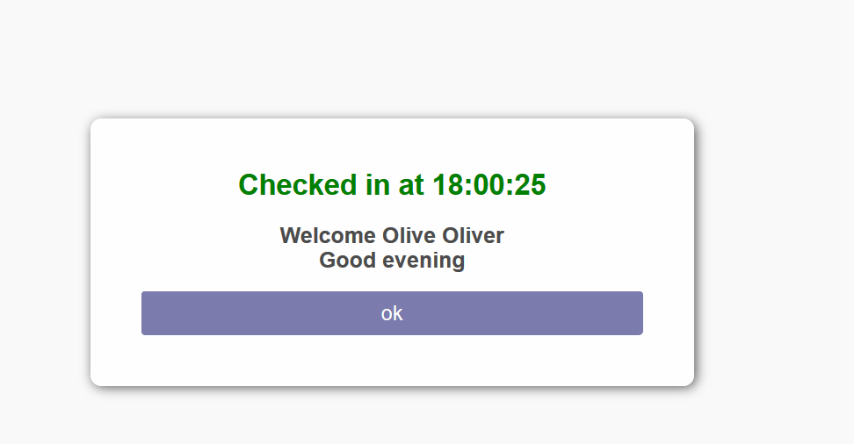

Figure 14 - Check in.

At the end of the month we will able to see the attendance report of the employees.

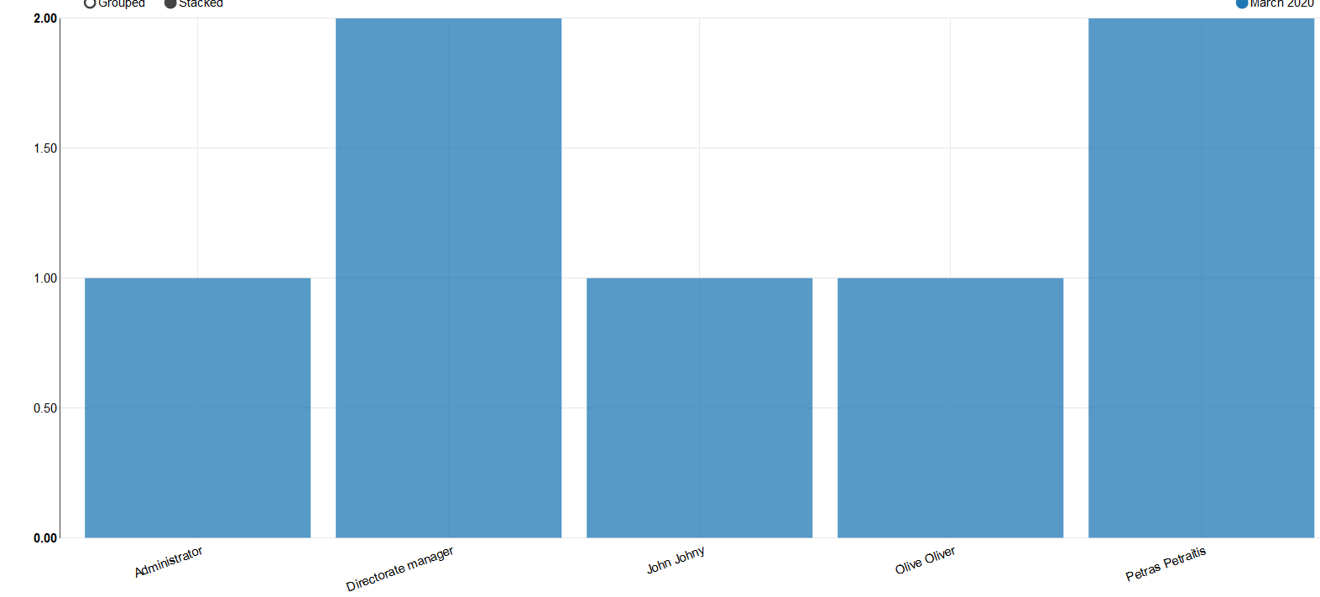

Figure 15- Attendance report

# 4.

|  |  |  |
| --- | --- | --- |
| ODOO module | What is configured | Comments |
| Sales | Allowed discounts, Tax included in the price, Shipping cost, Delivery date | In Lithuania tax is included in the price, It’s will easier for customer to know the full price of the product and delivery. |
| Inventory | Warehouse locations, Multiple warehouse. Lot and Serial numbers. | If the business expand, we would need more warehouse. |
| Invoice | Set currency to EUR, EU digital good VAT. | The company is in Europe and it’s better to have euros as main currency |
| Employees | Set working hours to 35 hour per week.  The Directorate manager can modify Employee’s attendance. |  |

# CONCLUSION

The additional chosen modules are Purchase management, Contacts and Email Marketing. Those modules helps to manage additional sales reports, contact vendors and market products through email. Allowed discount and Tax included are configured in the Sales module, Multiple warehouses locations are configured in Inventory module, Set currency in Eur in Invoice module and set 35 hours per week workday for Employees module.